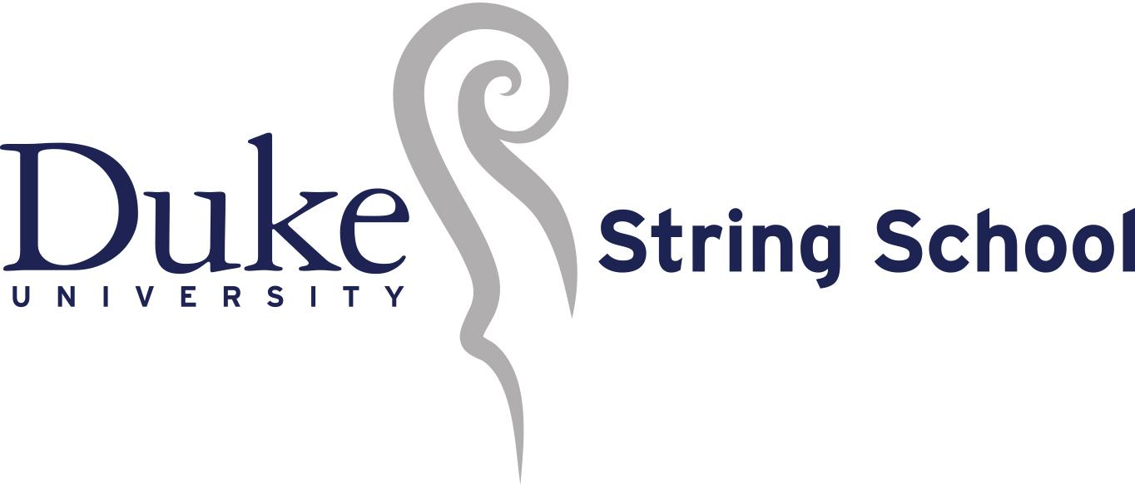
Concerto Competition
Saturday October 19, 2019, 1:30pm, Nelson Music Room
Winners will perform with the DUSS Concert String Orchestra and Youth Symphony
in Baldwin Auditorium at 6:30pm on February 22, 2020
Olivia Lee  Kai Wong  Annie Brooks  Sahana Ramamurthy  Evan MacDonald  Trisha Choudhary  Gerui Zhang  Matthew Erickson  Ann Darr  Dafne Delgado  Kabir Khwaja  Matthew Delaney  Jenny Cui  Amelia Cho  Maya Liu  Amelia Posner-Hess  Ganeesh Varadarajan  Alexander McDowell  Sriya Dhupati | La Folia  Cello Concerto No. 1 in A minor  Op. 33  I. Allegro non troppo  Andante e Rondo Ongarese Op. 35  Violin Concerto in A minor  BWV1041  I. Allegro  Violin Concerto in A minor Op. 82  I. Moderato  II. Andante sostenuto  Violin Concerto No. 4 in D minor  Op. 31  I. Andante  Romance in F major Op. 50  Violin Concerto in A minor Op. 82  I. Moderato  II. Andante sostenuto  Cello Concerto No. 1 in A minor  Op. 33  I. Allegro non troppo  ~ 10-minute intermission ~  Cello Concerto No. 1 in A minor  Op. 33  I. Allegro non troppo  Cello Concerto No. 1 in C major  I. Moderato  Violin Concerto in A minor  BWV 1041  III. Allegro assai  Symphonie Espagnole in D minor  Op. 21  I. Allegro non troppo  Violin Concerto No. 2 in G minor  Op. 63  I. Allegro moderato  Symphonie Espagnole in D minor  Op. 21  I. Allegro non troppo  Violin Concerto No. 1 in A minor  Op. 28  I. Allegro moderato  Violin Concerto in E minor Op. 64  I. Allegro molto appassionato  Violin Concerto Op. 14  I. Allegro  Violin Concerto No. 3 in B minor  Op. 61  I. Allegro non troppo | A. Corelli  C. Saint-Saëns  C. M. von Weber  J.S. Bach  A. Glazunov  H. Vieuxtemps  L. v. Beethoven  A. Glazunov  C. Saint-Saëns  C. Saint-Saëns  J. Haydn  J.S. Bach  E. Lalo  S. Prokofiev  E. Lalo  K. Goldmark  F. Mendelssohn  S. Barber  C. Saint-Saëns

Judges:
Harry Davidson, Professor at Duke University, Music Director and Conductor of Duke Symphony Orchestra
Hsiao-Mei Ku, Professor at Duke University, violinist of the Ciompi String Quartet
Peter Askim, Director of Orchestral Studies at NC State University

