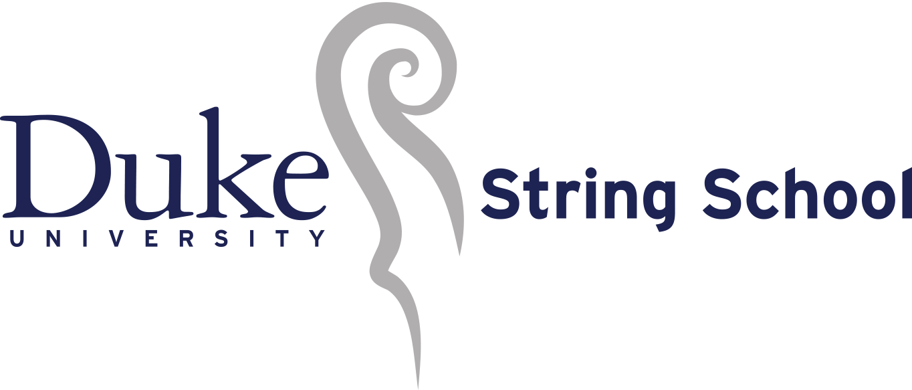

Violin and Cello Ensembles Concert

November 2, 2019, 4:00pm, Nelson Music Room

Beginner Violin

Erica Shirts, Conductor
1. Tiri Tiri Ti Ti Twinkle Instructional
2. GDG, DAD, AEA Instructional

Beginner Cello
Erica Leavell, Conductor
1. Steamroller Leap Frogs Carey Beth Hockett
2. Pre-Twinkle Express Longay

Cello Choir I
Carlos Bardales, Conductor
1. Lightly Row Folk Song 2. Lullaby Johanes Brahms
Soloist: Astrid Murrie, Theme from the New World Symphony by Antonin Dvorak

Violin Choir I
Nonoko Okada, Conductor
1. Bohemian Song Folk Song
2. Cuckoo Folk Song Soloist: Anulika Izuakor, Minuet 2 by J.S. Bach

Violin Choir II
Julia Reeves, Conductor
1. Come, Follow Traditional
2. The Rakes of Mallow Country Dance

Soloist: Royce Li, Witches Dance by N. Paganini

Cello Choir II
Carlos Bardales, Conductor
1. I've Got Homework Ricky Mooney
2. The Blacksmith Jorge Federik Haendel
Soloist: Henry Waggoner Rigadoon by Henry Purcell

Violin Choir III
Erica Shirts, Conductor

Soloist: Emily Thacker, Minuet by L. Boccherini
1. Surprise Symphony G. F. Haydn, arr.
2. The Two Grenadiers R. Schumann, cannon arr. by W. Starr

Erica Shirts, Director
Teachers: Carlos Bardales, Jasmine Campbell, Zachary Hobin, Erica Leavell, Shelley Livingston,
Nonoko Okada, Julia Reeves, Rob Rempher, Matt Stutzman, Maria Valencia.
Accompanists: J. Samuel Hammond, Eric Hochstetler
Staff Assistant: Katharine Whitmore, Parent Volunteer Coordinator: Angela Lopez
Founder & Director Emeritus: Dorothy Kitchen

Beginner Cello
Conducted by Erica Leavell

Sienna Khandani
Zachary Penner
Nadezhda Podolyansky
Evelyn Smith

Cello Choir I
Conducted by Carlos Bardales

TJ Afonso
Ella Cohen
David Durham
Hansong Kim
Astrid Murrie

Cello Choir II
Conducted by Carlos Bardales

Cyrus Gadbury
Hannah Khandani
Peyton Palmer
Kieran Rooney
Henry Waggoner

Beginner Violin
Conducted by Erica Shirts

Vivian Butterworth
Rebecca Dou
Ivy Fisher
Susannah Hochstetler
Haruki Homma
Lucy Johnsen
Aria Jones
Jessa Kernodle
Hankyul (David) Kim
Hannah Kim
Erick Landa Aguilar
Olen Monroe

Violin Choir I
Conducted by Nonoko Okada

James Adams
Sylvie Butterworth
Ruby Jean Fisher
Arabella Flores
Audrey Han
Amara Izuakor
Anulika Izuakor
Yejin (Sophia) Jo
Isabel Johnsen
Zoe Jones
Meg Lessard
Sophia Miller
Indrani Pai
Valentina Podolyansky
Dhruv Rao
Vanessa Shively
Charlie Smith
Jason Taylor

Violin Choir II
Conducted by Julia Reeves

Ilsa Bergman
Shael Diaz
Ryan Ge
Maya Giralt
Frank He
Neila Huang
Ashten Jampayas
Ian Lee
Royce Li
Luka Liu
Emma Ming
Rosie Peterson
Varunie Pai
Matila Reich
Patrick Swinney
Haochen Tang

Violin Choir III
Conducted by Erica Shirts

Zuri Davis
Zanadia Diaz-White
Isabel Halpern
Nafas Hayati
Alyssa Hearn
Owen Henderson
Teddy Hill
Jenna Kim
Anusha Raghunathan
Mira Rajagopal
Dhriti Rao
Emily Thacker
Xinyin Zhang

_____________________________

Many thanks to Angela Lopez and all the members of our volunteer parent committee, our fantastic accompanists, and Music Department folks, especially Rick Nelson, Elizabeth Thompson, and Gretchen Hoag, Jonathan Bagg, Eric Pritchard, Jane Hawkins Raimi (1950-2017),Vice Provost for the Arts Scott Lindroth, Dr. Phail Wynn (1947-2018), Sam Miglarese, and Dr. Stelfanie Williams for their support of DUSS and the Kidznotes Pipeline, and of course Founder and Director Emeritus Mrs. Dorothy Kitchen for founding this wonderful program.

